The data:
Predict students' dropout and academic success - UCI Machine Learning Repository
The data I researched has created from a higher education institution (acquired from several disjoint databases) related to students enrolled in different undergraduate degrees, and includes information known at the time of student enrollment (academic path, demographics, and social-economic factors) and the students' academic performance at the end of the first and second semesters.
introduction:
As a student, I can identify with the difficulties and pressures that may appear during academic studies. The student's personal situation may influence and even determine the degree of success of the student during the studies to a large extent. Many students come from different backgrounds, such as different economic status, different educational achievements, etc., which affect the extent of their investment in academic studies. The purpose of the research is actually to test the effect of various factors on the failure or success of the student to finish the degree. In order to test this, I asked 3 research questions.
שם: ליעד צור
ת"ז: 315368464
Final Project
The first research question focuses on the effect of the student's personal parameters, age, gender and scholarship on success or failure in studies and to understand whether an older student has fewer chances of success compared to a young student and also whether gender has an effect.
The second research question focuses on the effect of economic factors, student debt and GDP on the student's success or failure. The GDP represents a more general economic index and the student's debt represents a more personal economic index, therefore it is interesting to check the effect of the student's financial position which may be a critical factor in his success in graduating.
The third research question focuses on the effect of the academic achievements at the beginning of the academic degree, on the achievements in the second semester. The parameters that were tested are the grade in the first semester, the grade for admission to studies and special educational needs. Often a student whose academic achievements were high at the beginning of his studies, was not able to maintain the same level of achievements due to various factors, therefore it is interesting to see the student's level of consistency during his studies in regards to his academic achievements.
First research question
Research Question: Does a student's scholarship status, age at enrollment, and gender affect their chance of completing their studies?
Method: To answer the research question, I chose to characterize the posterior distributions of the parameters associated with scholarship status, age at enrollment, and gender. After fitting the model with the data, I extracted the posterior distributions to understand how each parameter influences a student's probability of graduating.
Likelihood Function: Given that '1' indicates 'graduated' and '0' represents 'not graduated, I chose to use the Bernoulli likelihood function fitted with a logit link.
Priors:
Scholarship holder: Normal, (0.5,1.5). My initial belief is that having a scholarship might have a positive influence on success.
Age at enrollment: Normal, (-1,2). A negatively prior was chosen based on the hypothesis that older age at the time of enrollment may decrease the chances of successfully complete their degree. The assumption here is that older students may have additional life responsibilities or challenges that could interfere with academic commitments, thereby affecting their graduation outcomes negatively.
Gender: Normal, (0,2). For gender, a non-informative prior was used, Since I did not have any knowledge or belief about this parameter and its effect on the success or failure of a student to finish the degree.
Results:
Scholarship holder: Coefficient: 1.48, HDI 95%: [1.28, 1.69]
A positive coefficient suggests that students with scholarships have a higher likelihood of graduating. The CI, which does not include zero, strengthens this finding.
Age at enrollment: Coefficient: -0.05, CI 95%: [-0.06, -0.04]
A significant negative correlation between age at enrollment and success. As the enrollment age rises, the likelihood of graduation diminishes.
Gender: (1 = male and 0 = female) , Coefficient: -0.80 , CI 95% : [-0.96, -0.65]. The negative coefficient indicates that male students are less likely to graduate than female.
Model Diagnostics:
Family: Bernoulli, Formula: Target ~ Scholarship.holder + Age.at.enrollment + Gender
Bulk_ESS: Scholarship holder - 3704, Age at enrollment - 4926, Gender – 3999
Tail_ESS: Scholarship holder - 3126, Age.at.enrollment - 3270, Gender – 2737
Rhat: 1.00 for all variables
Summary:
Gender: The findings suggest a distinct difference in academic outcomes between male and female students. Male students appear less likely to complete their studies than females. Despite the result, I think the question, to what extent gender has an effect on the chance of succeeding or failing to finish the academic degree, is worth checking in other universities around the world.
Scholarship holder: The results show that students with scholarships tend to do better academically than those without. These results may indicate the importance of the scholarships that the university grants to students, and their contribution to academic achievements.
Age at enrollment: The analysis shows a subtle but significant inverse relationship between age at enrollment and the probability of graduation. This could potentially be due to a variety of factors such as increasing life commitments, reduced academic flexibility and so. 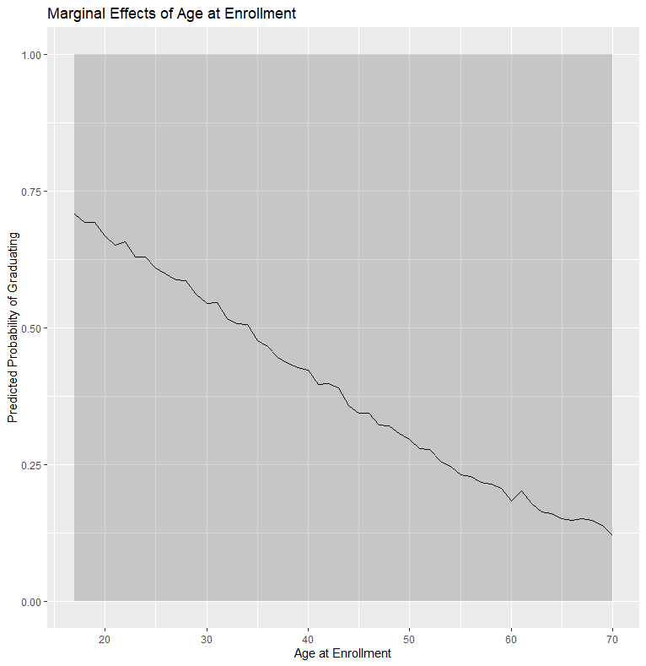
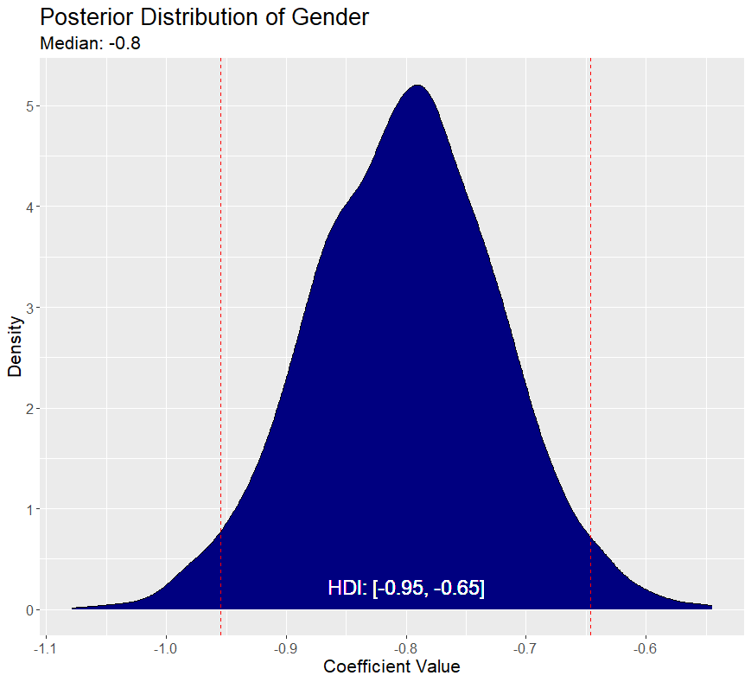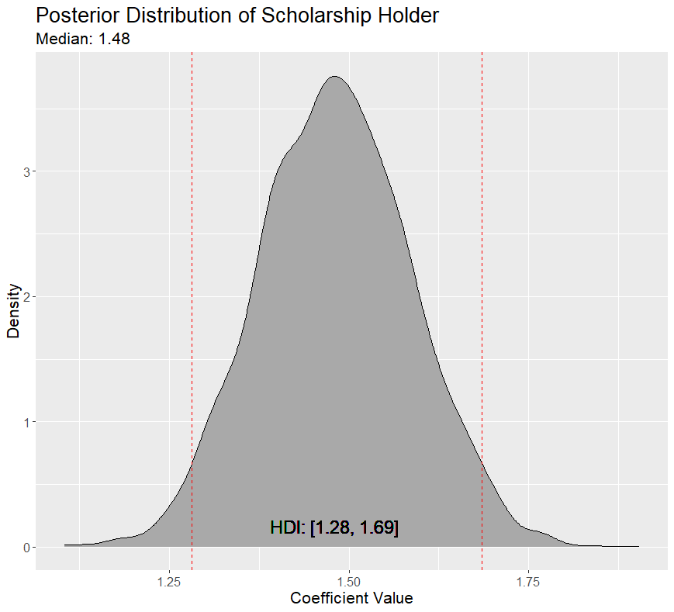
Second research question
Research Question: How does a country's GDP and a student's debtor status influence the likelihood of successful academic outcomes?
Method:
To address the research question, I used the posterior predictive distribution method. By employing a Bernoulli likelihood function with a logit link, I modeled the academic outcomes (1=graduated, 0=not graduated).
Likelihood Function: I selected the Bernoulli likelihood function with a logit link due to the binary outcome variable: successful academic outcomes (yes(1) or no(0)).
priors:
GDP: Normal (0, 2). I chose to use a non-informative prior, because I have no knowledge or belief about the impact of GDP on the student's success in completing the degree.
Debtor Status: Normal (0, 2). I chose a non-informative prior, because I have no knowledge or belief in the impact of debt on a student's success in completing their degree.
Results:
GDP: Coefficient: 0.06, 95% CI: [0.03, 0.09]
The positive coefficient suggests that a higher GDP corresponds to a marginally better academic outcome for students. From the posterior predictive checks, the effect of GDP on academic success isn't clear. The model shows varied probabilities across GDP levels, indicating no straightforward influence of GDP on academic outcomes.
Debtor: Coefficient: -1.79, 95% CI: [-2.03, -1.56]
The negative coefficient shows that students with debt are less likely to achieve positive academic outcomes. The posterior predictive distribution yielded two lines corresponding to the two-debtor status (0 and 1). For non-debtors, the predictive interval extended towards a higher likelihood of academic success. for debtors, the predictive interval skewed downwards.
Model Diagnostics:
Family: Bernoulli, Formula: Target ~ GDP + Debtor
Bulk_ESS: GDP - 4869, Debtor – 4069
Tail_ESS: GDP - 3131, Debtor – 2822
Rhat: 1.00 for all variables
Sensitivity Analysis: I performed a sensitivity test, with more informative priors(GDP(4, 2),Debtor(-2,2)) reflecting beliefs that a higher GDP has a positive effect on academic success and that being a debtor has a negative impact on the student. The sensitivity test reinforces the model's conclusions. Although I used different priors, the relationships between GDP, debtor status, and academic success remain consistent.
Summary:
GDP's Impact on Academic Success: While the model suggests a slight positive correlation between a country's GDP and academic success, the posterior predictive distribution muddies this clarity, showing a range of probabilities across GDP levels. Consequently, although there is a direction of influence, it lacks statistical significance, making the relationship between GDP and academic outcomes less definitive.
Debtor Status and Academic Success: The model confirms that having debt significantly lowers the chances of academic success. This assertion is further corroborated by the posterior predictive distribution, which shows that the probability of successful academic outcomes is notably lower for debtors.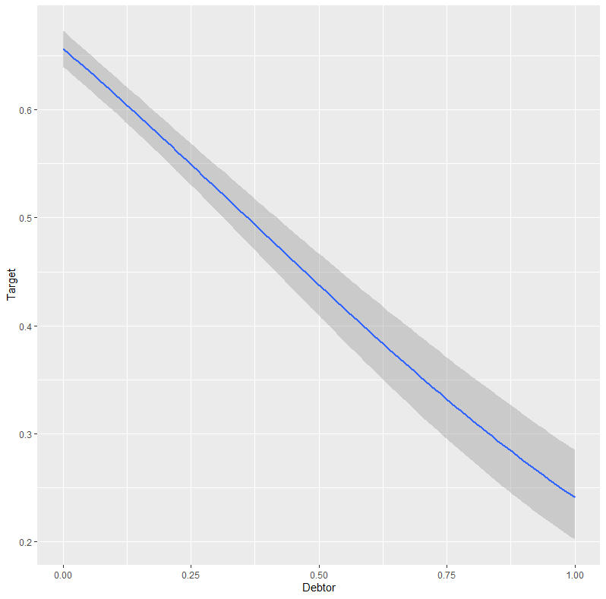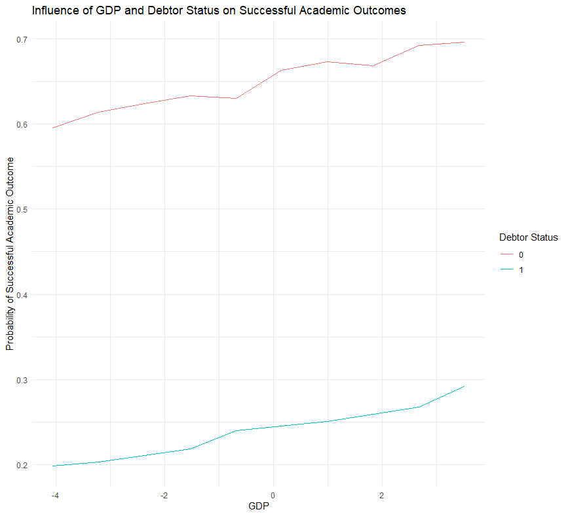
Third research question
Research Question: To what extent is a student's academic performance in the second semester influenced by their performance in the first semester, their admission grade, and any special educational needs?
Method: I compared two models, each aimed at understanding the determinants of academic performance in the second semester. Model M1 focused solely on the first semester's grade, while Model M2 added additional variables, such as admission grade and special educational needs. Finally, in order to compare the models, I used WAIC, LOO, and Bayes factor.
likelihood function:
The data analysis revealed that the grades are distributed normally, so I chose to use a Gaussian distribution as the likelihood function.
priors:
First semester grade: I set a prior as normal (2,2) based on my belief that good performance in the first semester is likely to positively influence performance in the second semester.
Admission grade: I chose to use the non-informative prior normal (0,5), since I am not sure that the admission grade indicates the student's achievements later in the degree, and I have no belief about it.
Educational special needs: I chose to use the non-informative prior normal (0,5). It is not clear to me the effect of educational study needs, since students with such needs receive lenient benefits such as extra time on the test, which may balance out their difficulties during their degree studies. so, I chose to let the data speak for itself.
Results:
For Model M1:
First semester grades: coefficient: 0.70 , 95% CI: [0.67, 0.72].
For Model M2:
First semester grades: coefficient: 0.67, 95% CI: [0.65, 0.70]. slightly drops but remains significant.
Admission grade: coefficient: 0.01, 95% CI: [0.00, 0.01].
Special educational needs: coefficient :0.15, 95% CI: [-0.16, 0.47].
Model Diagnostics:
Model M1 (Family: Gaussian, Formula: second semester grade ~ first semester grade):
Bulk_ESS: Intercept - 3625, first semester grade - 3616
Tail_ESS: Intercept - 2661, first semester grade - 2729
Rhat: 1.00 for all variables
Model M2 (Family: Gaussian, Formula: second semester grade ~ first semester grade + Admission grade + Educational special needs):
Bulk_ESS: Intercept - 4210, first semester grade - 3759, Admission grade - 4255, Educational special needs - 3872
Tail_ESS: Intercept - 3498, first semester grade - 2580, Admission grade - 3398, Educational special needs - 2818
Rhat: 1.00 for all variables
Model Comparison:
Using the WAIC and LOO metrics, Model M2 demonstrated a slight advantage over Model M1. Specifically, the difference in expected log predictive density (elpd_diff) between M2 and M1 was -14.1, with a standard error of 6.2. Additionally, the Bayes factor is supporting the advantage of Model M2, with a value of 0.00754.
Predictive Checks:
Prior predictive checks and posterior predictive checks were performed on both models. The results of the tests supported the findings, y and y_pred converge almost perfectly, which indicates that the model fits well.
summary:
The results show that most of the impact on the grade in the second semester will come as a result of the grade in the first semester, which indicates that a student who finishes the first semester with a good grade may generate positive momentum for continuing the degree. The admission grade has a positive but very weak effect, which shows that the admission grade does not necessarily indicate the student's achievements in further studies in the degree. The relationship between special educational needs and a student's chances of success in completing the degree is not statistically significant, and does not indicate a statistically significant relationship between a student's special educational needs and his academic achievements. Overall, Model M2, which includes all predictors, is slightly favored over M1.
